I233018
Abdul Basit
Lab 2
Operating System

Task1 :
1)First five lines of the file.
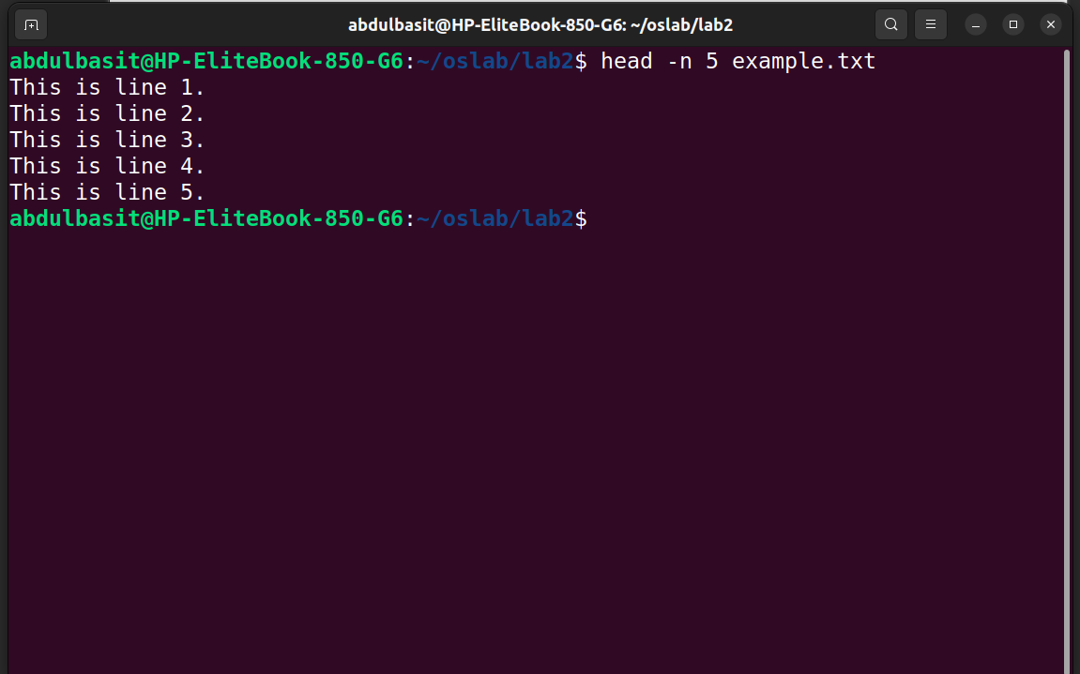

2)First 10 lines

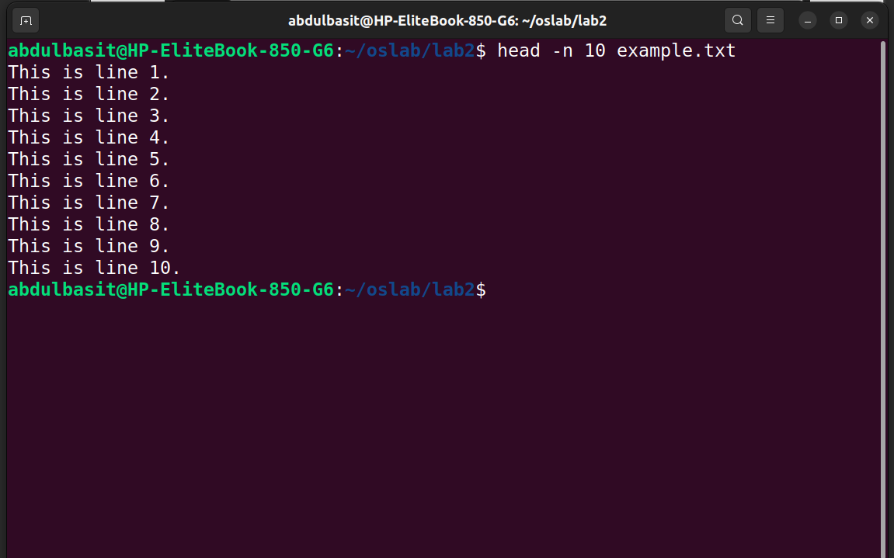
3)last 5 lines

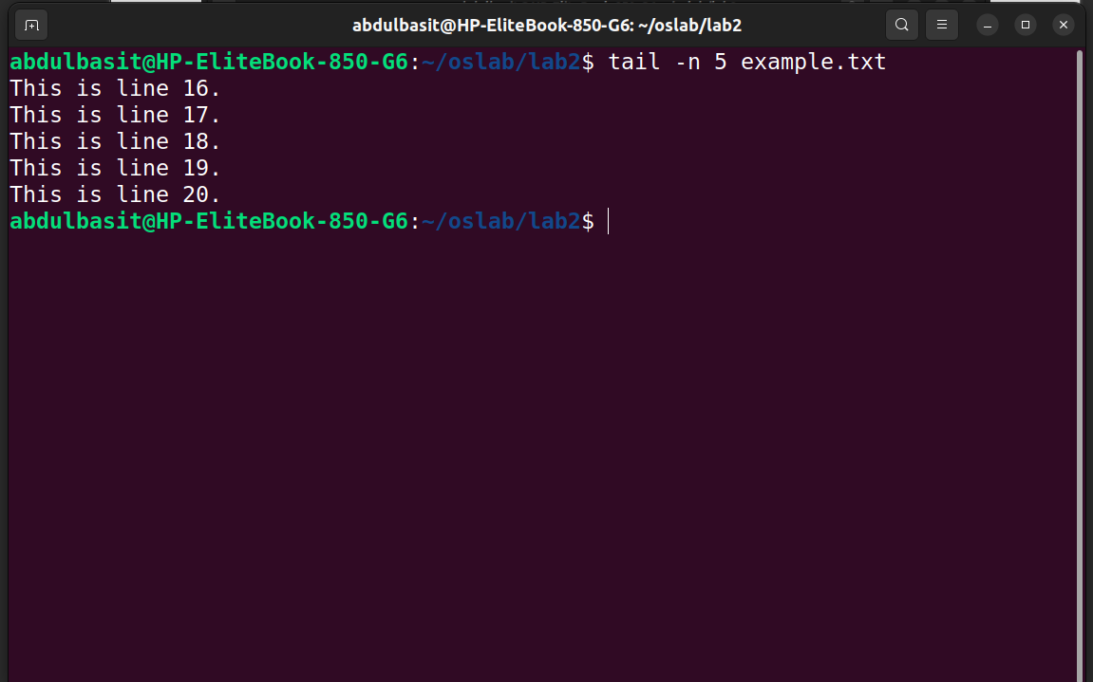
4)lines 6-10

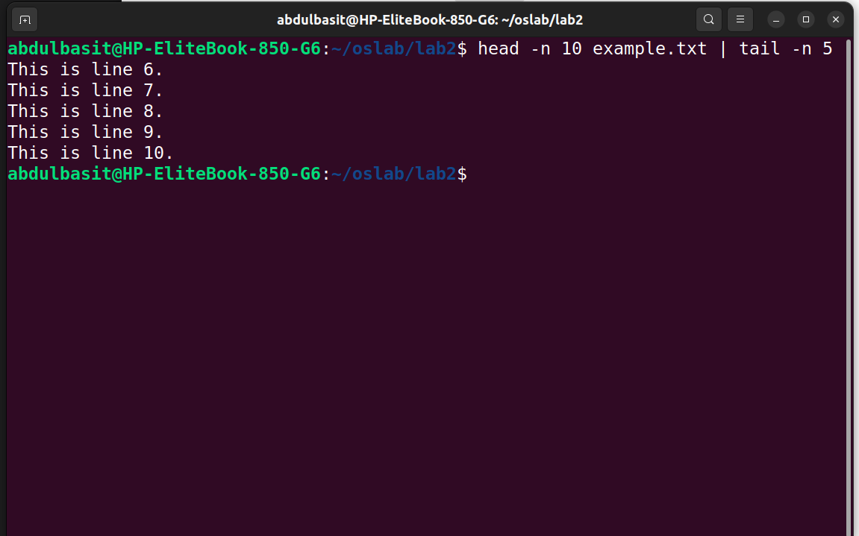
5)First 100 bytes
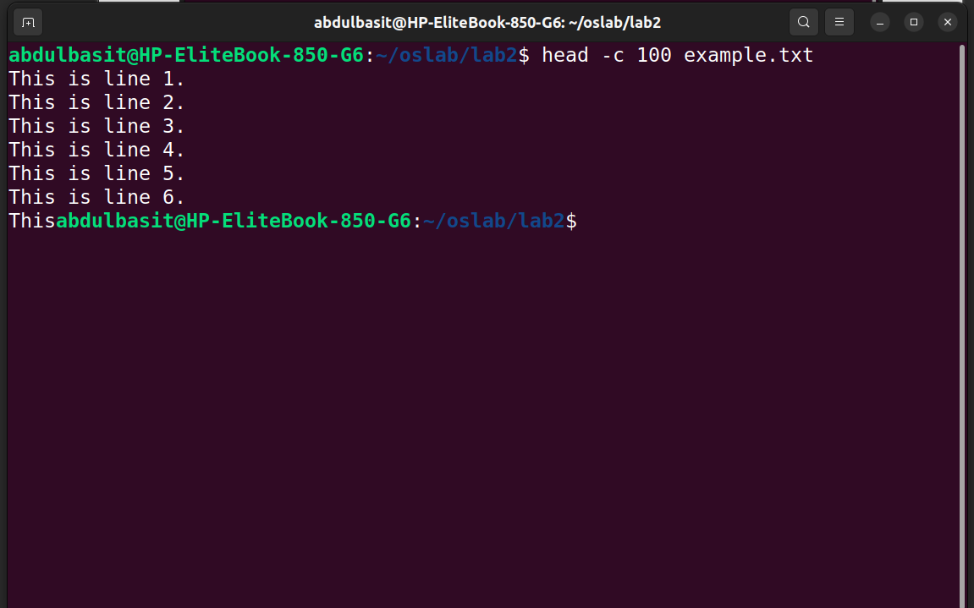
6)last 100 bytes
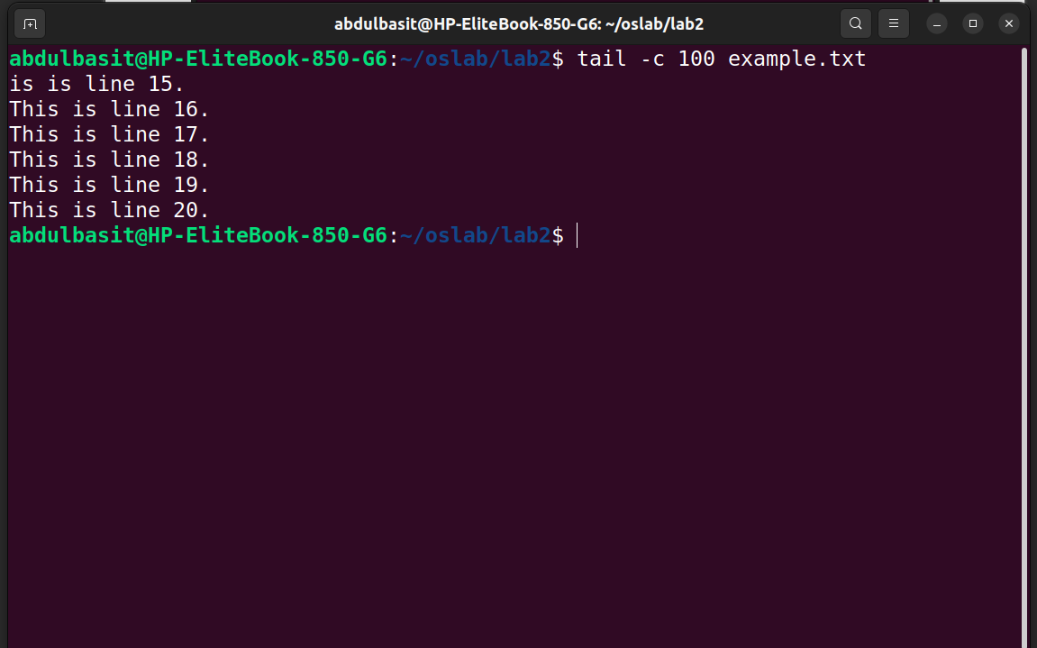
TASK2)
1)first 3 lines of both
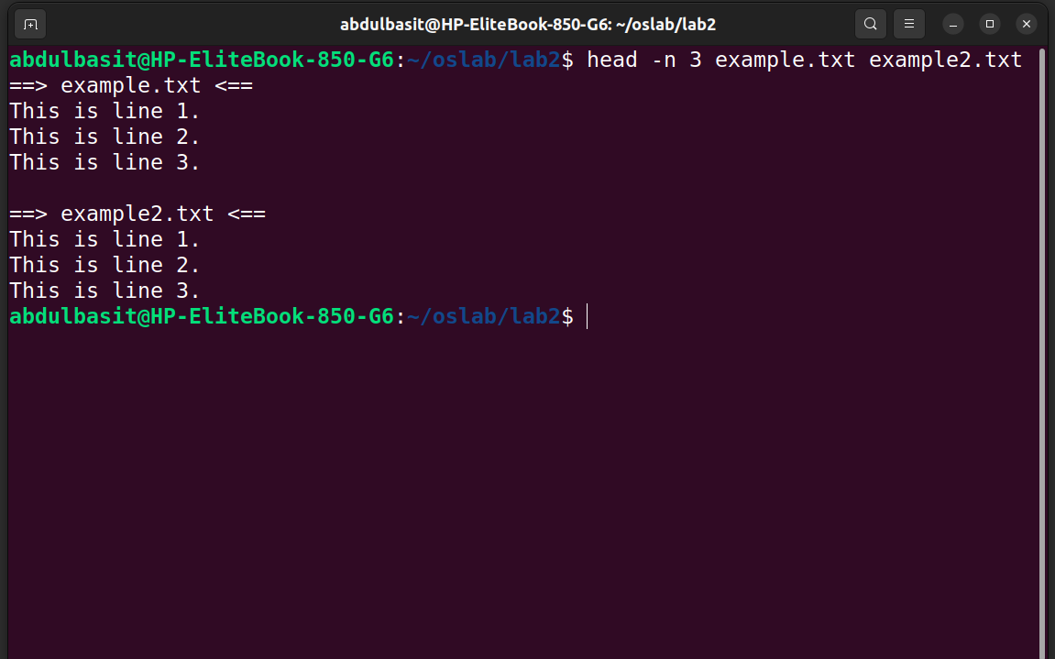

2)last 3 of both
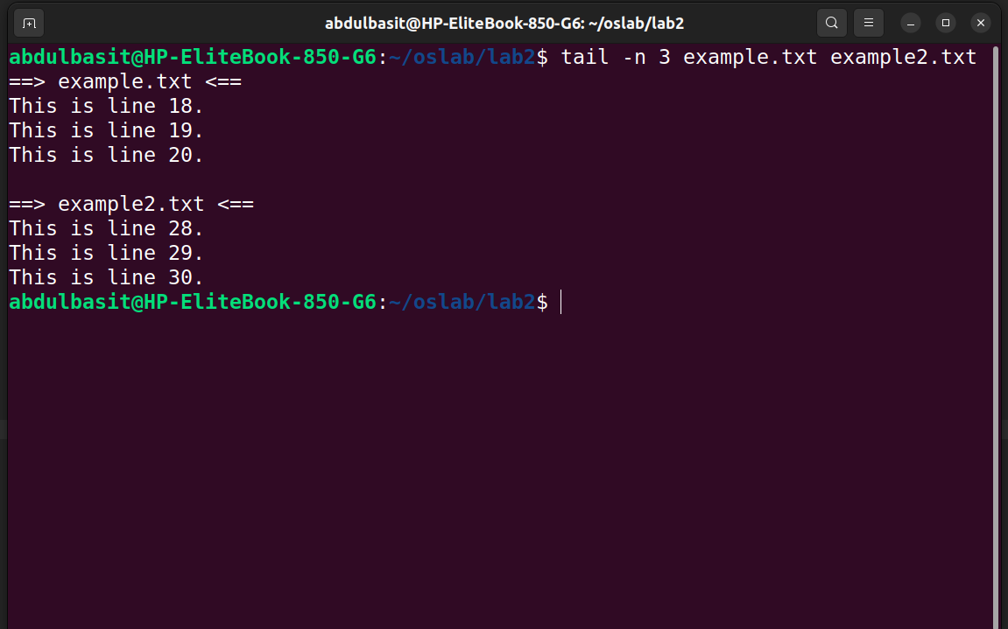
3)search example in home
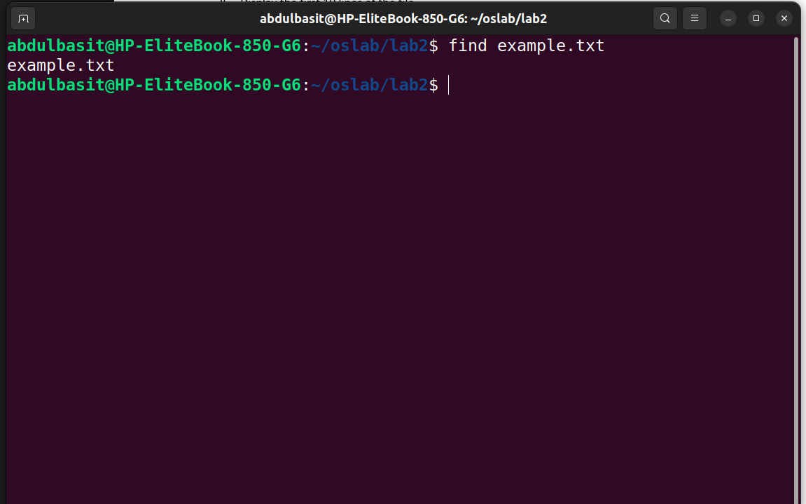
4)Find all .txt files in the /home/user/documents/ directory.
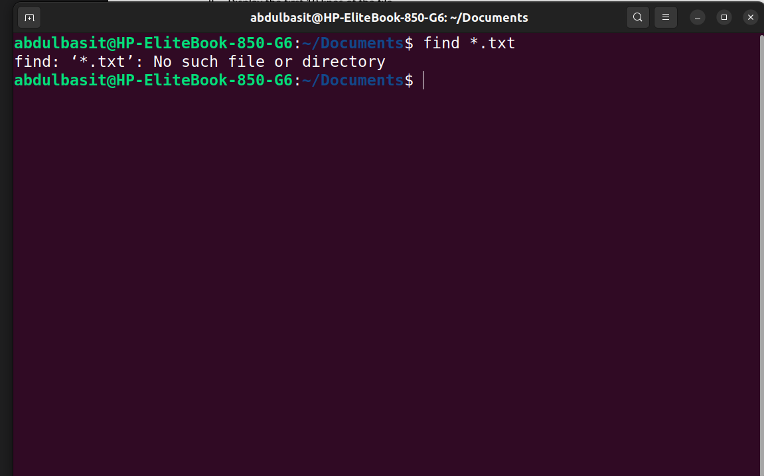
5)Find all files larger than 100MB in the /var/log/ directory.

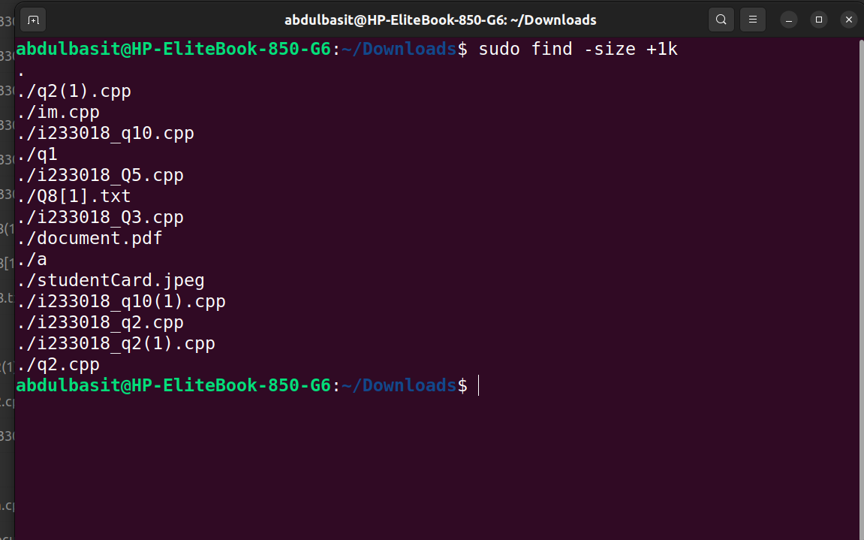

6)Find all files smaller than 1KB in your current directory.
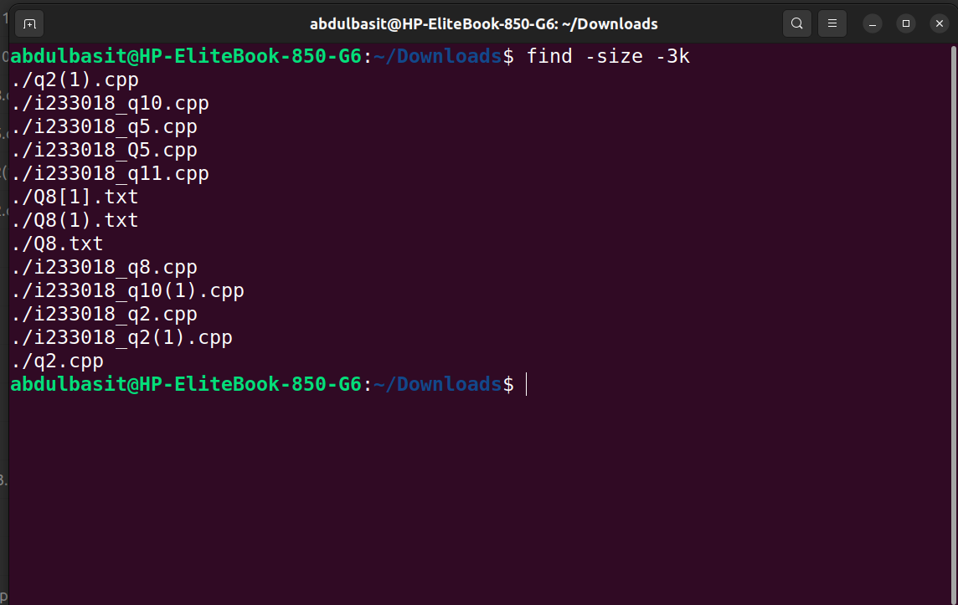
7)Find all empty files in /var/ directory.
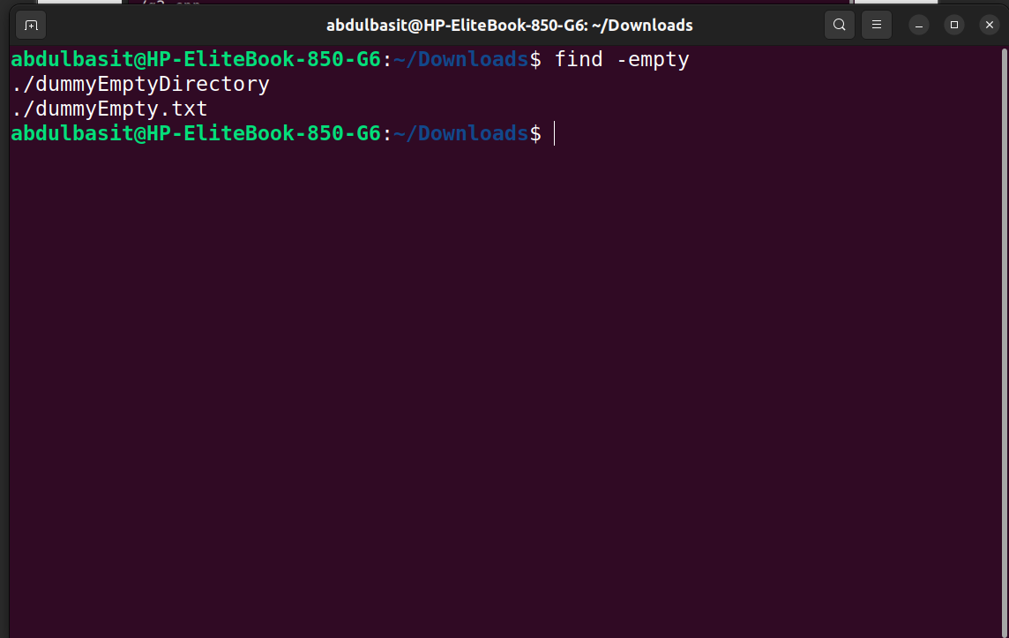
8)Find all empty directories in home
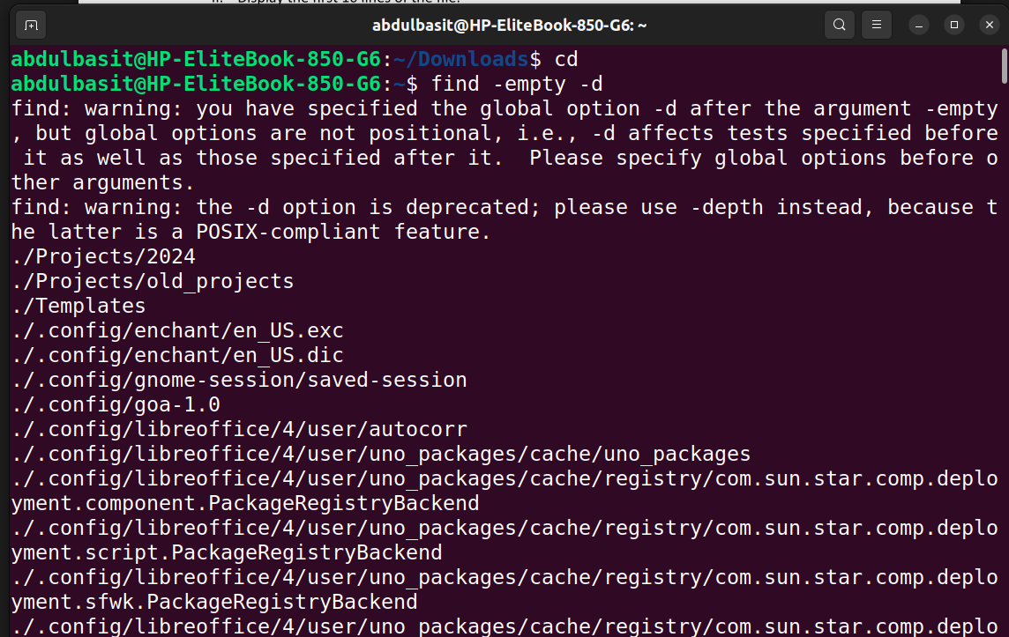
9)Change the permissions of example.txt so that only the owner has read, write, and execute
permissions, while the group and others have no permissions. Using octal number.
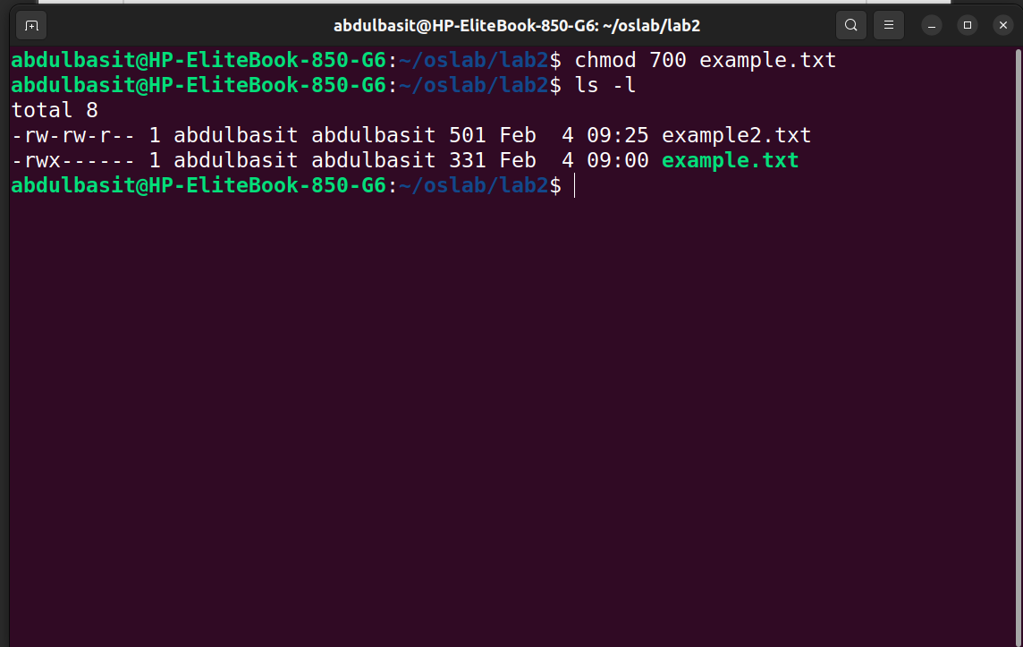
10)XVI. Change the permissions of example.txt so that everyone (owner, group, others) has read and
write permissions. Using octal number
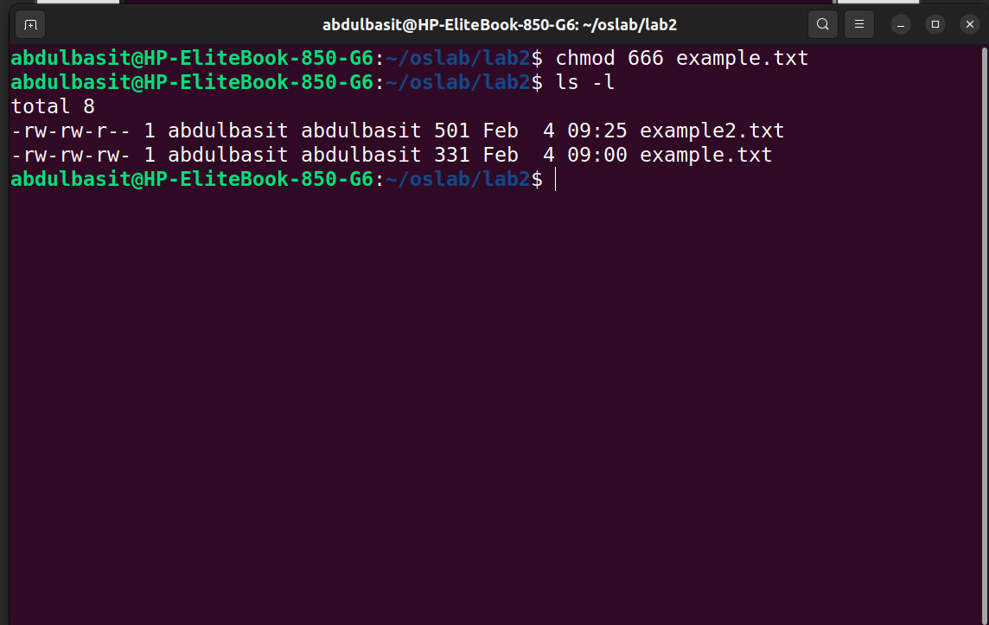
11)Change the permissions of example.txt so that it is read-only for the owner, group,
and others. Using octal number.
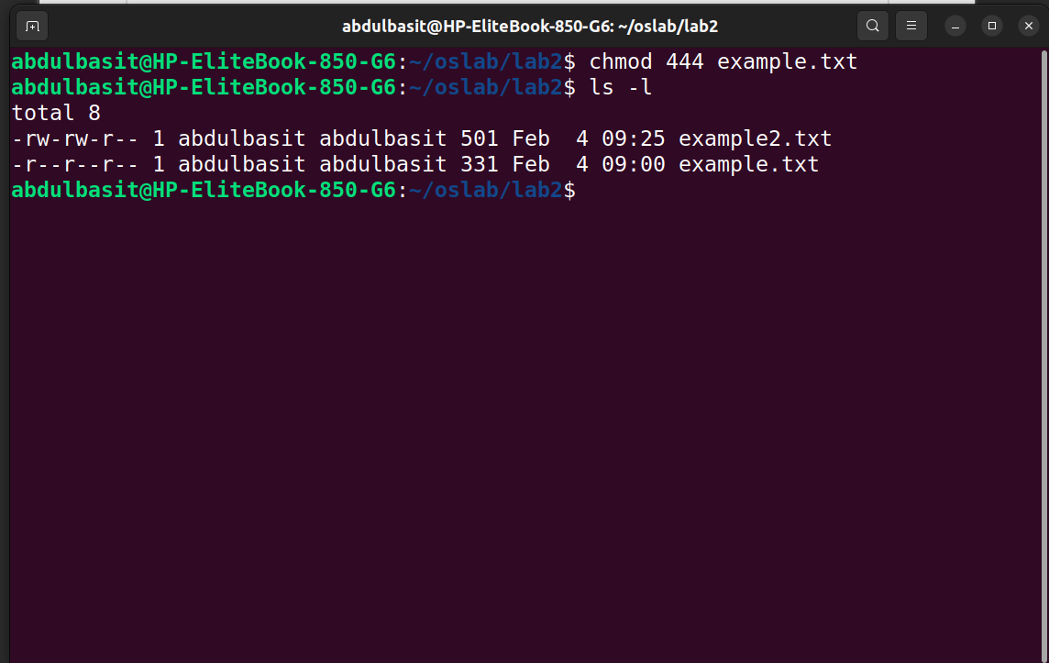
12)Others have no permissions

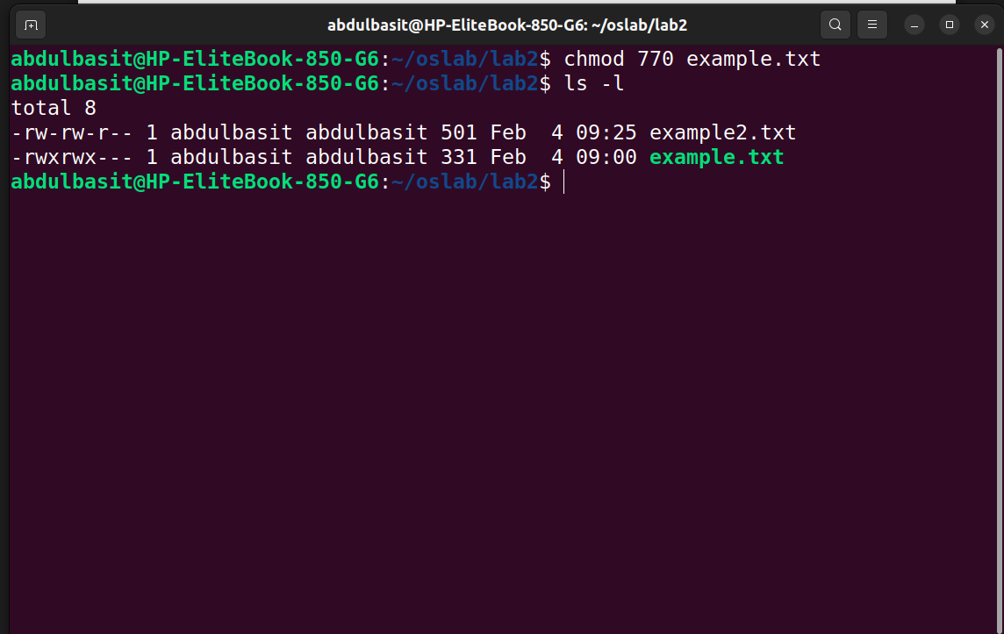
13)Change the permissions of example.txt so that the group and others lose their write
permissions but retain any other existing permissions.
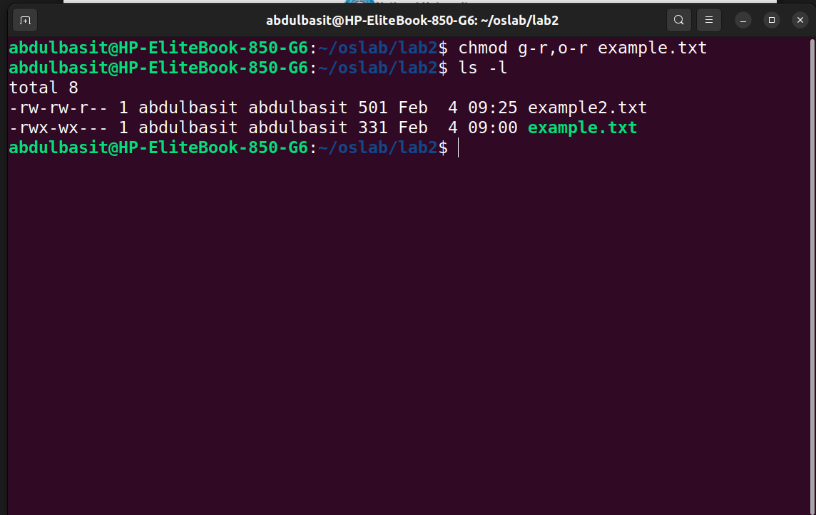
14)Use symbolic notation to give the owner execute permission, the group read and execute
permissions, and others only execute permission.
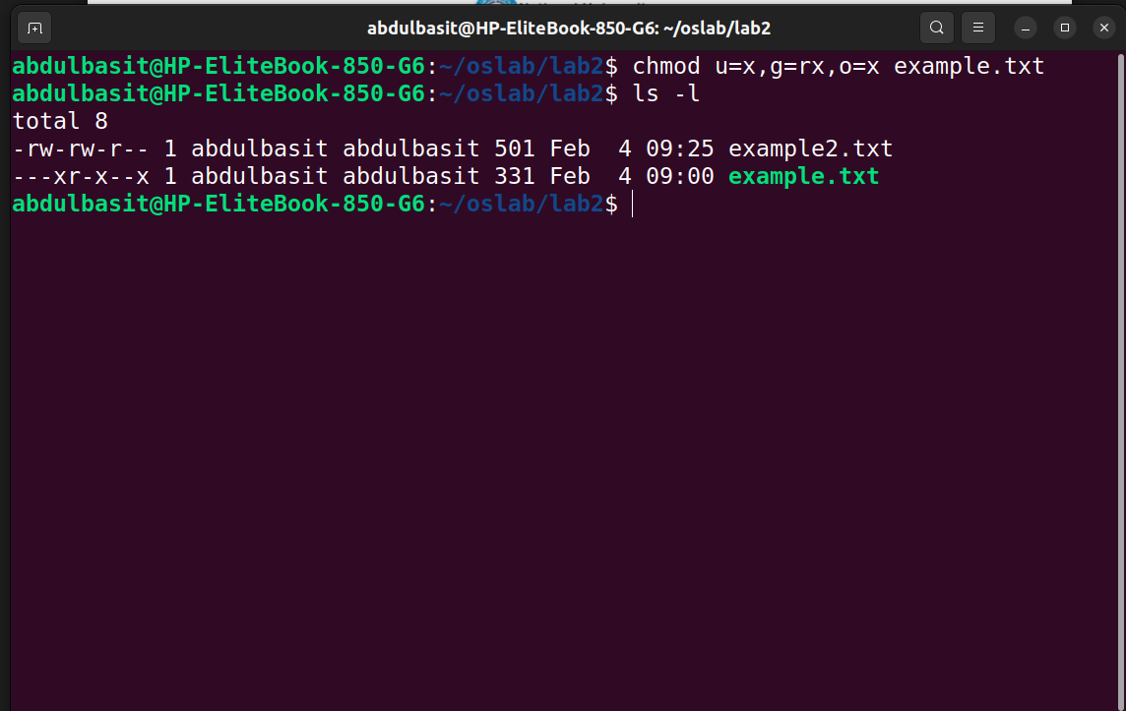
15)Change the permissions of example.txt so that everyone (owner, group, others) can execute the
file, without affecting other permissions. Without using u, g and o.
